**TiGERS**



Tiffany Goldmine Environmental Management Report System

**CSSE7024 User Manual (Environmental Officers)**



Wei Yeap Cheng (Nicholas),  
Jane Harrison,   
Xing-Shu Liu,   
Justin Mancinelli,   
Chih-Hsiang Tang (Sean) and   
Dell Topel

Tiffany Gold Mine Environmental Management Reporting System – User Manual

1 Getting Started 3

2 Administration of TiGERS Data 3

2.1 Adding and Updating a Contractor 3

2.2 Adding and Updating and Deleting a Water Body 4

2.3 Adding and Updating and Deleting a Sampler 5

2.4 Viewing Contractor Information 7

2.5 Viewing Water Body Information 7

2.6 Viewing Sampler Information 7

2.7 Viewing Sampler Media 8

2.8 Viewing Sampling Frequency Schedules 8

3 Generating Reports 9

3.1 Generating an Exceedance Report 9

3.2 Generating an Environmental Audit Report 9

4 Executing a Screening Program 10

# Getting Started

TiGERS is a web based application. In order to use it, you must be able to use the internet and have a username and password given to you by the system administrator. The following are basic instructions on how to start the application, log in, update your password and log out. Later sections detail what you may do after you have logged in. 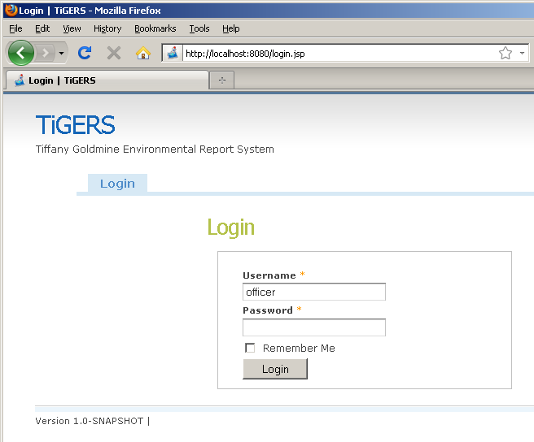

1. Open a web browser installed on your computer
2. Enter the location of the TiGERS application as directed by the System Administrator. (If TiGERS is running on your local machine, the address will be like “<http://localhost:8080>” otherwise it will be like “<http://tigers.tiffanymine.com.au>”)
3. You will be presented with the Log In screen where you must enter the Username and Password given to you by the system administrator
4. After entering your username and password, click the Login button to access the system. (Optionally, you may click the “Remember Me” check box to tell the application that you would like to stay logged in after closing the web browser)
5. You will see the welcome screen that includes a navigation menu at the top.
6. The main menu tab gives you the ability to change your password and log out.
   1. Update Password – Clicking on this menu item will bring up a screen with the fields Password and Confirm Password. You must enter the same password in both fields in order to update your password. Click save when you are ready to update the password.
   2. Log Out – Clicking on this menu item will log you out of the application. You will be presented again with the Login screen.

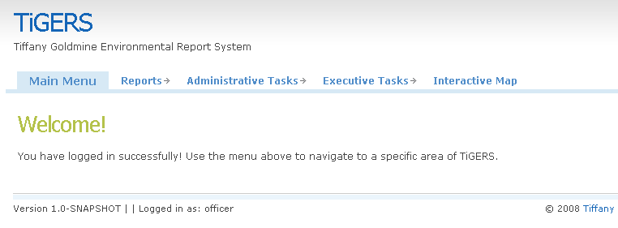

# Administration of TiGERS Data

Environmental officers have the privilege of viewing and modifying several key Data of TiGERS. This data consists of Sampler, Water Body, and Contractor data.

## Adding and Updating a Contractor

Contractors collect samples for analysis and can upload information about the sampling locations (samplers) assigned to them.

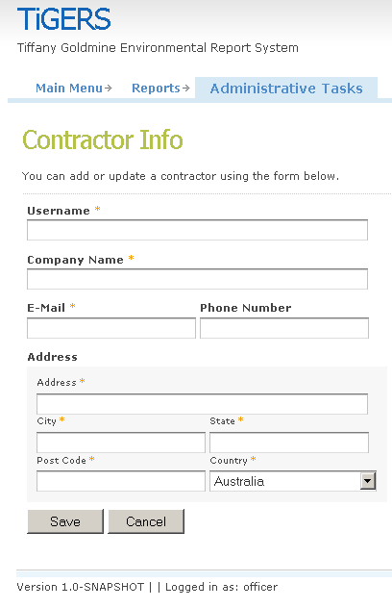To add a contractor to TiGERS, go to the Add Contractor screen. This can be found through the main menu as “Administrative Tasks 🡪 Add Contractor”. After inputting relevant information, click the Add button to commit the addition. The Add Contractor form expects the following data (required fields are prefixed with ‘*’)

* \***Username** – Used for the contractor login   
  (at most 20 alphanumeric characters)
* \***Company Name** – Name of the company the contractor works for  
  (at most 50 alphanumeric characters)
* \***E-Mail** – E-Mail address of the contractor  
  (at most 60 alphanumeric characters of the form [abc@domain.tld](mailto:abc@domain.tld))
* **Phone Number** – Primary contact number of the contractor  
  (must be 10 digits)
* **Address**
  + \***Address** – Building number and street address where contractor can be reached  
    (at most 100 alphanumeric characters)
  + \***City** – City associated with above Address  
    (at most 50 alphanumeric characters)
  + \***State** – State associated with the above City  
    (at most 100 alphanumeric characters)
  + \***Post Code** – Post Code associated with the above Address, City, and State  
    (at least 4 digits)
  + \***Country** – The country associated with the above State  
    (choose a country from the drop-down list)

After adding a contractor, you will be redirected to the View Contractors screen as described below.

To update a contractor, first visit the View Contractors screen, search for the contractor you wish to modify, then click on the appropriate row of the table. The update screen is the same interface as the add screen described above but fields will be populated with current values. Modify the fields you require then click the Save button.

If you wish to cancel an Add or Update, click the Cancel button and you will be redirected to the main menu.

## Adding and Updating and Deleting a Water Body

Water Bodies contain samplers which are used to collect samples for analysis. They Have various parameter thresholds associated with them.

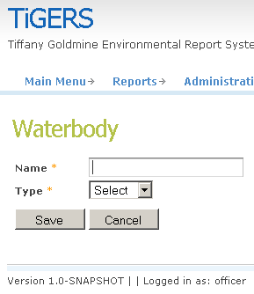To add a water body to TiGERS, go to the Add Water Body screen. This can be found through the main menu as “Administrative Tasks 🡪 Add Water Body”. After inputting relevant information, click the Add button to commit the addition. The Add Water Body form expects the following data (required fields are prefixed with ‘*’)

* \***Username** – Used for the contractor login   
  (at most 20 alphanumeric characters)
* \***Type** – Whether this is a ground water or surface water type  
  (choose a type from the drop down list)

After adding a water body, you will be redirected to the View Water Bodies screen as described below.

To update or delete a water body, first visit the View Water Body screen, search for the water body you wish to modify, then click on the appropriate row of the table. The update screen is the same interface as the add screen described above but it also contains fields for Parameter Thresholds and all fields will be populated with current values. Modify the fields you require then click the Save button. The fields for Paramter Thresholds each have a **Minimum** and **Maximum** value (all fields must contain positive numbers, Maximum must be larger than Minimum, and all fields are required)

* 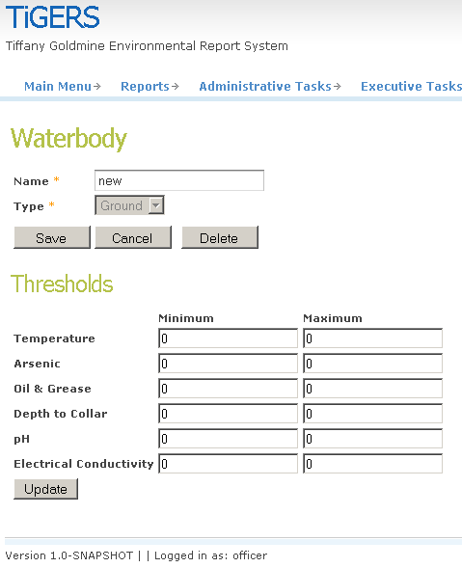\***Temperature** – The safe temperature range  
  (must be a number of the form NNN.NN)
* \***Arsenic** – The safe arsenic range  
  (must be a number of the form NN.NNN)
* \***Oil & Grease** – The safe oil and grease range  
  (must be a number of the form NNN)
* \***Depth to Collar** – The regulated depth of water from collar  
  (must be a number of the form NNNNN)
* \***pH** – The safe pH range  
  (must be a number of the form NNN.NN)
* \***Electrical Conductivity** – The safe electrical conductivity range  
  (must be a number of the form NNNNN)

If you wish to delete the water body, click the Delete button.

If you wish to cancel an Add or Update, click the Cancel button and you will be redirected to the View Water Body screen.

## Adding and Updating and Deleting a Sampler

Samplers are used to collect samples for analysis. They are associated with a particular water body and contractor. Contractors should acquire samples from each sampler at the specified sampling frequency for each parameter associated with the sampler.

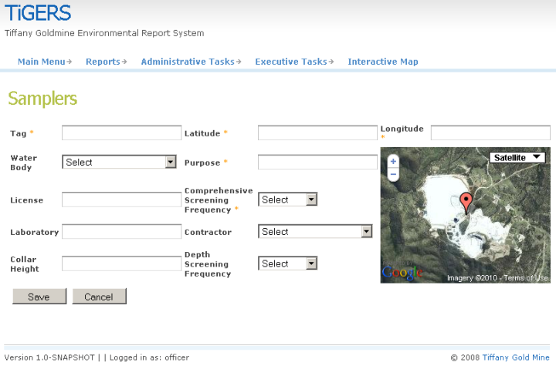To add a sampler to TiGERS, go to the Add Sampler screen. This can be found through the main menu as “Administrative Tasks 🡪 Add Sampler”. After inputting relevant information, click the Add button to commit the addition. The Add Sampler form expects the following data (required fields are prefixed with ‘*’)

* \***Tag** – Unique ID   
  (must be 5 alphanumeric characters)
* * **Latitude** – Latitude of sampler’s location  
  (must be a number of the form NN.NNNNNN, in the range -90 to 90)
* * **Longitude** – Longitude of sampler’s location  
  (must be a number of the form NN.NNNNNN, in the range 0 to 180)
* **Water Body** – Primary contact number of the contractor  
  (choose a water body from the drop down list)
* **Purpose** – The reason for adding this sampler  
  (at most 50 alphanumeric characters)
* **License** – License number of sampler  
  (required for samplers associated with ground water bodies, at most 20 alphanumeric characters)
* **Comprehensive Screening Frequency** – How often this sampler should be sampled for a comprehensive screening of parameters  
  (choose a frequency from the drop down list)
* **Laboratory** – The laboratory tasked with testing samples from this sampler  
  (this field is not editable, it only exists for informational purposes)
* **Contractor** – The contractor tasked with taking samples from this sampler.   
  (choose a contractor from the drop down list)
* **Collar Height** – The height of the collar above sea level  
  (required for samplers associated with ground water bodies, must be a number of the form NNNNN)
* **Depth Screening Frequency** – How often this sampler should sampled for depth of the water below the collar height  
  (required for samplers associated with ground water bodies, choose a frequency from the drop down list)

The **latitude** and **longitude** fields may be populated by dragging the marker on the map. After adding a sampler, you will be redirected to the View Samplers screen as described below.

To update a sampler, first visit the View Samplers screen, search for the water body associated with the sampler you wish to modify, then click on the appropriate row of the table. The update screen is the same interface as the add screen described above but fields will be populated with current values (the additional Screening Frequencies button is described below). Modify the fields you require then click the Save button.

If you wish to delete the sampler, click the Delete button.

If you wish to cancel an Add or Update of sampler data, click the Cancel button and you will be redirected to the View Samplers screen.

If you wish to modify the screening frequencies associated with a sampler’s parameters, click the Screening Frequencies button. You will be presented with a list of current screening frequencies for the current sampler (which can be clicked to 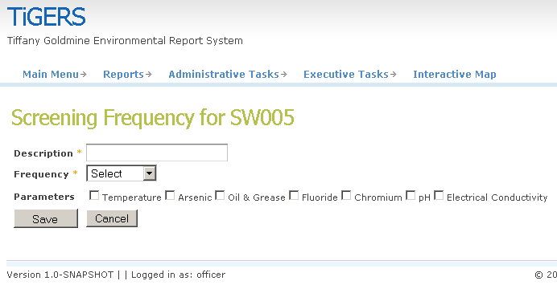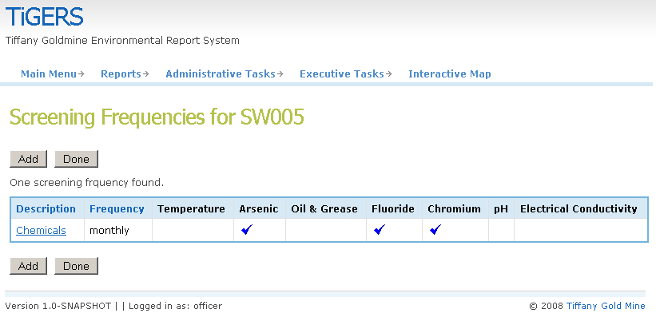modify its data) and the ability to add new screening frequency data. Screening frequency data consists of the following data (required fields are prefixed with ‘*’)

* \***Description** – Describe the reason for this screening frequency  
  (at most 20 alphanumeric characters)
* \***Frequency** – The frequency at which this screening should occur  
  (choose a frequency from the drop down list)
* \***Parameters** – The parameters which must be sampled for this screening  
  (check the boxes next to the relevant parameters, at least one must be selected)

If you wish to cancel an Add or Update of screening frequency data, click the Cancel button and you will be redirected to the Screening Frequencies screen.

It is also possible to add a Sampler via the Interactive Map. See the appropriate section below for more information.

## Viewing Contractor Information

To view all contractors, go to the View Contractors screen. This can be found through the main menu as “Administrative Tasks 🡪 View Contractors”.

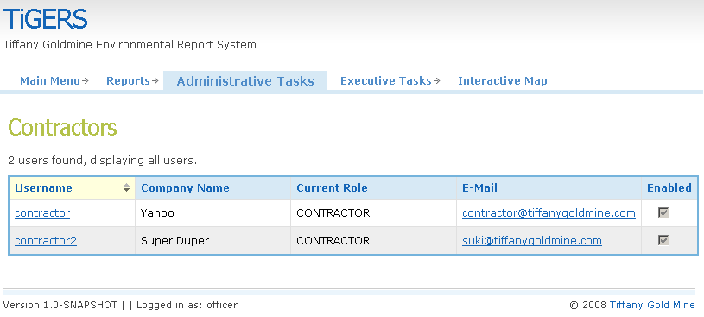Here you will see a search field and a table with descriptive headings. The search field can be used to narrow the range of results shown in the table by listing contractors associated with the given water body.

## Viewing Water Body Information

To view all water bodies, go to the View Water Bodies screen. This can be found through the main menu as “Administrative Tasks 🡪 View Water Bodies”.

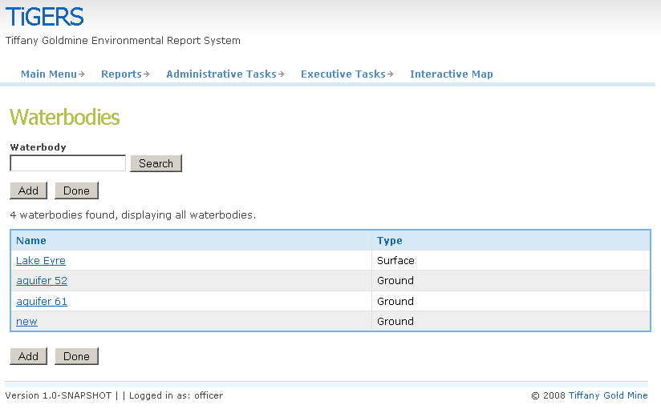Here you will see a search field and a table with descriptive headings. The search field can be used to narrow the range of results shown in the table by listing based on a specific water body.

## Viewing Sampler Information

To view all samplers, go to the View Samplers screen. This can be found through the main menu as “Administrative Tasks 🡪 View Samplers”.

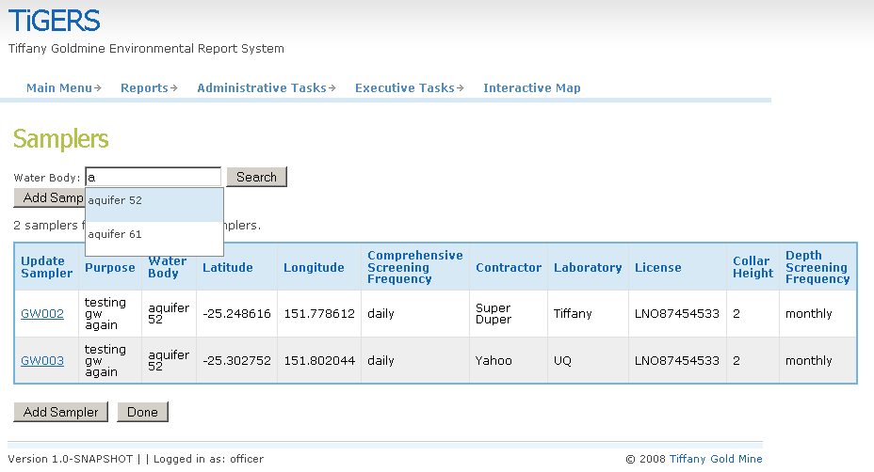Here you will see a search field and a table with descriptive headings. The search field can be used to narrow the range of results shown in the table by listing samples associated with the given water body.

It is also possible to view Sampler Information via the Interactive Map. See the appropriate section below for more information.

## Viewing Sampler Media

To view all samplers, go to the View Sampler Media screen. This can be found through the main menu as “Administrative Tasks 🡪 View Sampler Media”.

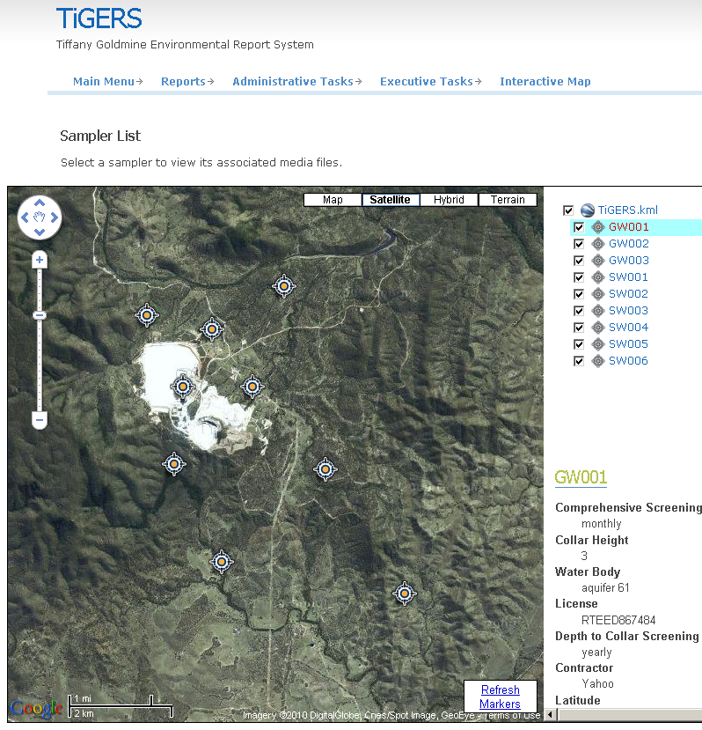Here you will see list and map of samplers. Click on the relevant sampler in the list or on the map.

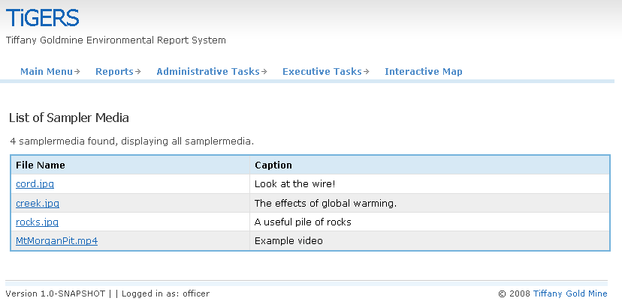You will then be directed to a list of sampler media files. Click on the name of the file you wish to view and it will be overlayed on the screen. You may right-click and choose “Save Link As…” if you wish to save the file locally.

## Viewing Sampling Frequency Schedules

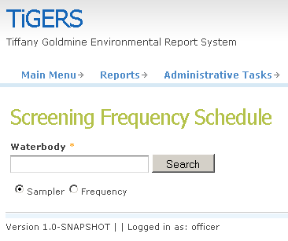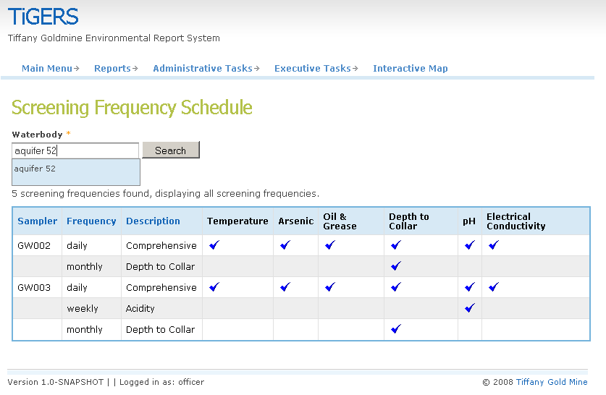To view the sampling frequency schedules, go to the Screening Frequency Schedule screen. This can be found through the main menu as “Administrative Tasks 🡪 Schedule of Sampling Frequency”.

Here you will see a search field that will allow you to narrow the range of sampling frequencies on the next page. You may also choose a parameter by which to order the sampling frequencies. After choosing the water body and ordering parameter, click the Search button.

The page will then be updated with a list of screening frequencies found for that water body. Sampling parameters with a checkmark are associated with the frequency indicated in the Frequency column of the table.

## Viewing, Updating, and Adding Sampler Information via the Interactive Map

To view, update, or add sampler information via the map, go to the Interactive Map screen. This can be found through the main menu as “Interactive Map”.

Here you will see a satellite view of the Tiffany Gold Mine site which will automatically zoom to show all samplers. On the right of the map, there is a list of samplers which have been loaded from the KML file and an information frame which shows non-empty parameters associated with the currently selected sampler.

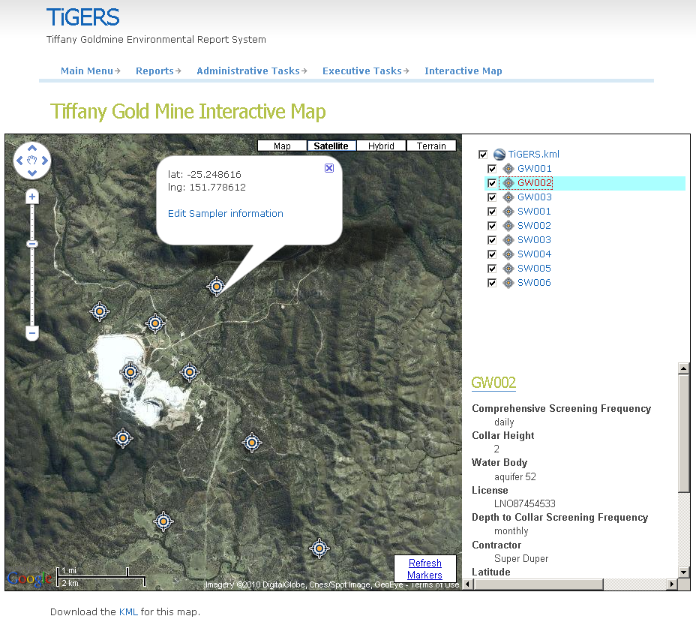The map also allows you to pan, zoom and change map type. To pan, you can either click and drag the mouse on the map or click the arrows within the circle of the top-left control. To zoom, you may either use your mouse’s scroll wheel or click the ‘+’ or ‘-’ buttons on the zoom control, or click the zoom control itself on the left of the map. To change map type, click on the type you wish to view using map type control at the top-right. The default map type is “Satellite”, to view road information choose the “Map” type, to view both satellite and road information, choose the “Hybrid” type, and to view topographical information, choose the “Terrain” type.

### Viewing Sampler Information via the Interactive Map

To download the KML file for use in Google Earth, click the link underneath the map. To select a sampler for viewing information, place the mouse over the sampler in question either from its icon on the map or its tag in the list. The information is scrollable to view further parameter information which cannot fit within the space.

If you have reason to believe that sampler locations have been modified, you may click the “Refresh Markers” link in the bottom-right corner. This will reload an updated KML file based on the current state of the data.

### Updating Sampler Information via the Interactive Map

Clicking on a sampler icon from the map, or a tag in the list will pop-up a comment box on the map indicating the latitude (lat) and longitude (lng) of the sampler which was clicked along with a link to edit the sampler information which will bring you to the Update Sampler screen as described above.

### Adding Sampler Information via the Interactive Map

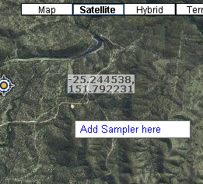You will notice that moving the mouse cursor within the map will display the current latitude and longitude under the cursor. This is most useful when you wish to add a sampler via the map interface.

To add a sampler at the indicated location, right click on the map. A context menu will appear with the option to “Add Sampler Here”. Click on this option to be directed to the Add Sampler screen as described above.

# Generating Reports

## Generating an Exceedance Report

To generate an exceedance report, go to the Create Exceedance Report screen. This can be found through the main menu as “Reports 🡪 Create Exceedance Report”.

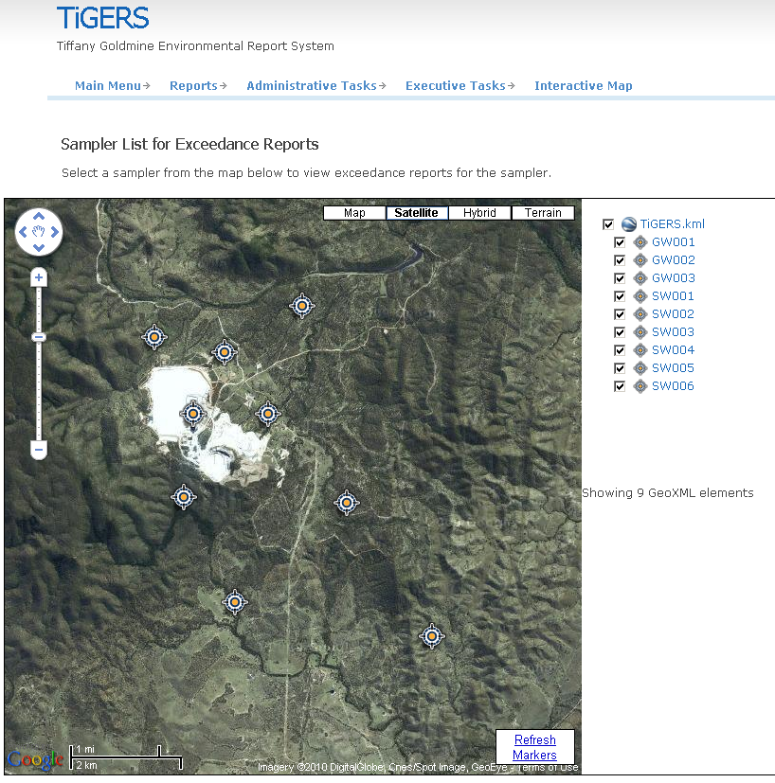Here you will see list and map of samplers. Click on the relevant sampler in the list or on the map. You will then be directed to the exceedance report screen.

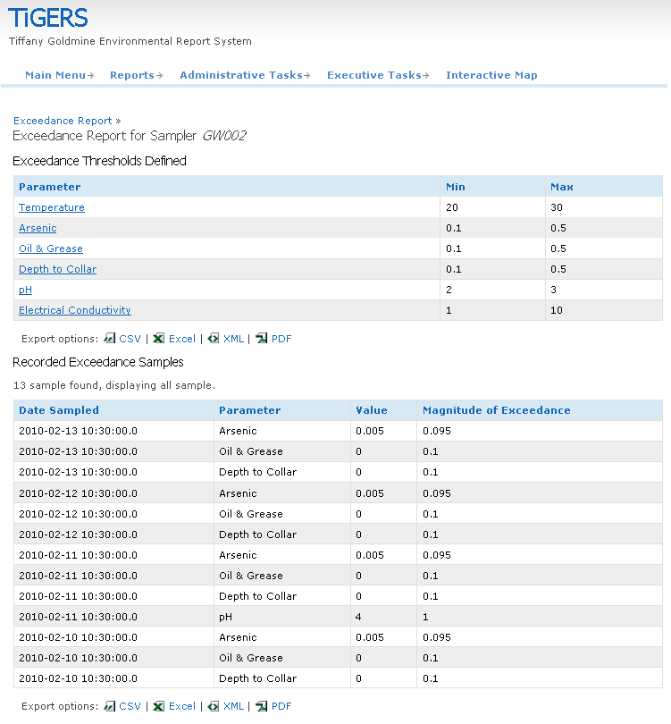The table at the top of the screen defines the exceedance thresholds for parameters of the current sampler. Clicking on a row of this table will direct you to the Update Water Body screen as described in the previous section.

The table at the bottom of the screen displays all samples that have exceeded the defined parameter thresholds. A sample that has multiple parameters outside the exceedance threshold will appear in multiple rows.

## Generating an Environmental Audit Report

To generate an environmental audit report, go to the Create Environmental Audit Report screen. This can be found through the main menu as “Reports 🡪 Create Environmental Audit Report”.

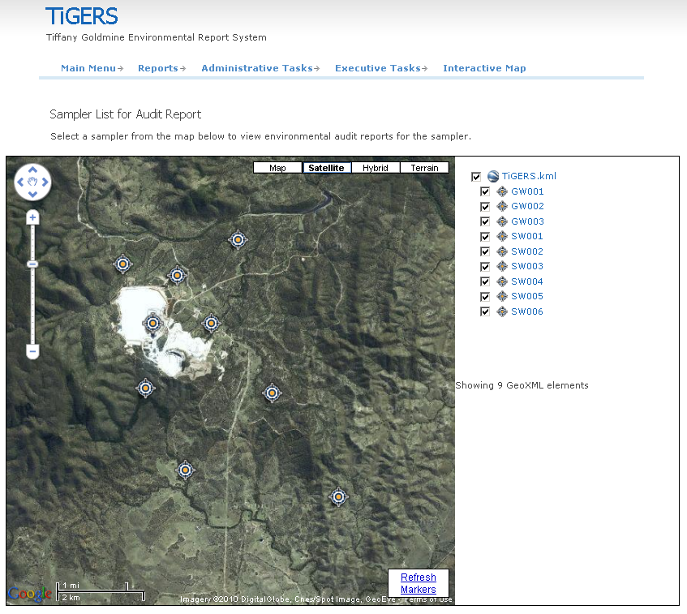Here you will see list and map of samplers. Click on the relevant sampler in the list or on the map. You will then be directed to the environmental audit report screen.

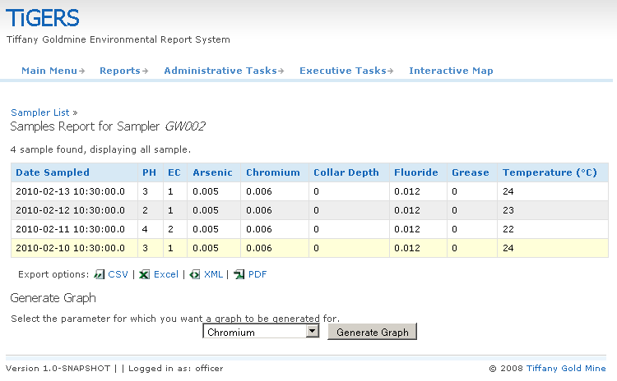The table on this screen displays all samples associated with the current sampler and their parameter values.

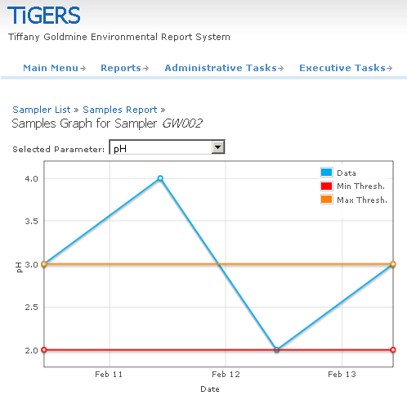To generate a graph representation of the environmental audit report, select a parameter to graph and click the Generate Graph button. You will be directed to the Samples Graph screen where you can see an interactive graph of the parameter chosen for all samples of the current sampler. Place the mouse cursor over a circle on the blue line to get information about the date the sample was taken and the value obtained on that date. You may also select a different parameter to view from this screen via the drop down box above the graph.

# Executing a Screening Program

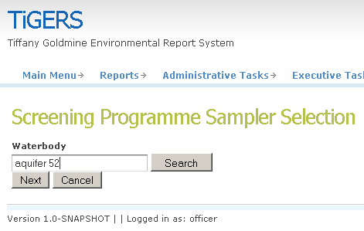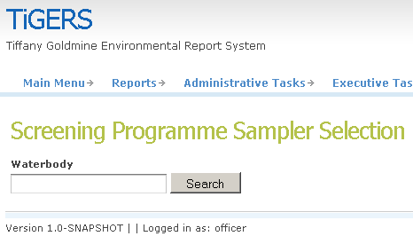To execute a screening program, go to the Start New Screening Program screen. This can be found through the main menu as “Executive Tasks 🡪 Start New Screening Program”

You must first select a water body to start the screening program. After searching for a water body successfully, you will be presented with Next and Cancel buttons.

While executing a screening program, please do not press the back button or navigate to another page unless you first press the Cancel button. Pressing the Cancel button will bring you back to the welcome screen where you can then navigate the application normally. Pressing the Prev button will take you to the previous page viewed within the screening program.

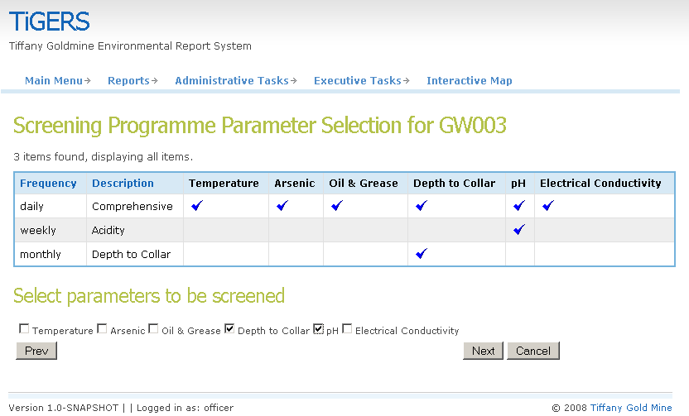Pressing the Next button will take you one-by-one through each sampler, showing you the sampling frequencies associated with that sampler and allow you to choose which parameters should be screened in the current screening program. Continue 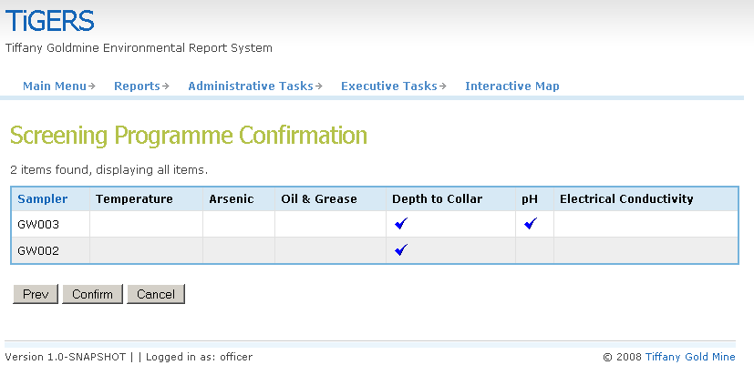this process until you have reached the Screening Program Confirmation screen.

The Screening Program Confirmation screen reports the samplers and associated parameters that belong to the current screening program. To confirm this screening program, press the Confirm button. After confirming, you will be taken back to the Welcome screen.

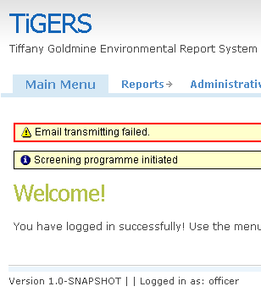Transparently, the application will send each contractor (based on the samplers in the screening program) an email indicating which parameters must be sampled at which samplers. If any of the email operations fails you will get an error message this could be because the email system is not working or the email address does not exist.